Name _________________
MAT 201 Midterm (Online Class)
Please work out all of the given problems. Credit with be based on the work that is shown that contributes towards the final answer. If you are using the calculator to solve a problem, be sure to write down what you are putting in your calculator. Also show all normal and Student T diagrams.

Problem 1 (20 Points) (For each part be sure to write down the sampling distribution for each, put in your normal curve diagram, answer the question and determine whether the normality assumption was needed.) The mean weight of an adult cat is 8.9 pounds and suppose the standard deviation is 1.2 lbs. Assume that the distribution of weight for adult cats is normal.
- If randomly weigh 44 adult cats, what is the probability that their average weight is greater than 8.8 pounds.?

- $\overline{x}\sim N\left(8.9,\frac{1.2}{\sqrt{44}}\right)=N(8.9,0.1809)$

- 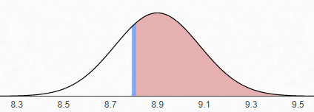

- Normalcdf(8.8,999,8.9,0.1809) = 0.7098

- Since the sample size is 44 > 30, the Central Limit Theorem tells us that the sampling distribution is normal. The normality assumption is not needed.

- Find the 12th percentile individual adult cat weight.
1.$X\sim N\left(8.9,1.2\right)$
2. 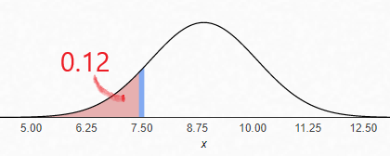
3. invNorm(0.12,8.9,1.2) = 7.49
4. Since we are only looking a single individual, the Central Limit Theorem does not apply. Therefore, the normality assumption was necessary.

Problem 2 (20 Points)
In average 7 people per day die in fires in the US. Politicians are considering turning off the power on windy days to decrease this average, but will first do it for a sample of days to see if it is effective.

- Discuss the implications of a Type I Error.

This means that the researchers concluded that turning off the electricity was effective when it wasn’t. Millions of Americans will have to go without electricity when it does nothing to prevent fires. This can cause havoc on society.

- Discuss the implications of a Type II Error.

This means the researchers were not able to conclude that turning off electricity was effective when it was. They won’t turn off the electricity when that would have prevented the fires. People will die unnecessarily.

- Suppose that the US implements the power outage policy for 35 randomly selected days and on those days an average of 6.3 people died per day and the standard deviation was 2.4. Test the hypothesis using α = 0.05. Be sure to state the null and alternative hypothesis, the p-value, and the test you are using in your calculator. Then state your conclusion using a complete sentence in the context of the study.
$$H_{0}: μ=7$$
$$H_{1}: μ<7$$
I used the t-test and got a p-Value of 0.0467 < 0.05.
Therefore the null hypothesis is rejected. There is statistically significant evidence to conclude that the population mean number of people who die due to fire will be less than 7 if the power is shut off during windy days.

Problem 3 (3 Points Each) Please circle the following True or False.
- The expected value for the number of times per year that people do something that they later regret is 28. Then if you take a sample of 300 people they will on average do 28 things over the year that they later regret.

. True False

- Eighty randomly selected reported car accidents will be looked at to see how much the insurance companies will end up having to pay. Then this procedure results in a binomial distribution. True False

- If x is a random variable that follows a normal distribution with mean 8 then
P(x < 10) = P(x > 6) True False

- If the mean amount of money people spend at a fast food restaurant is $6.50 and the standard deviation if $1.20. Then the sampling distribution of samples of size 9 of money spent at a fast food restaurant has mean $6.50 and the standard deviation of $0.40. True False

- If you want to used systematic sampling to test a sample of 1000 of the 50,000,000 iPhones to see if they will still work after being left out in a rainstorm, you should take every 50,000th iPhone that comes off the assembly line.
True False

- A researcher will be asking 78 randomly selected Americans if they have climbed Mt. Everest. Since the sample size is larger than 30, the Central Limit Theorem can be used to conclude that the sampling distribution is normal.
True False
- A gym manager will be giving a presentation on the number of minutes customers spend at the gym on their workout. The audience knows statistics well. A box plot should be used to best display the middle 50% of the minutes spent and a histogram should be used to best display that the minutes spent follows a Normal distribution.

True False

- If 37% of all people receive full health care benefits from their employer and 13% of all people have seen a medical provider at least once in the last month, then 50% of all people either receive full health care benefits from their employer or have seen a medical provider at least once in the last month.
True False

Problem 4 (20 Points) Suppose that the age of student at the local middle school follows a uniform distribution between 11 and 14 years old.

- What is the probability that a randomly selected local middle school student will be between 12.2 and 13.5 years old? Be sure to include your diagram.
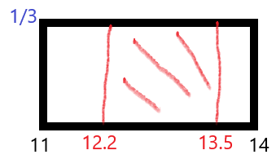
First find the height using $A=bh, 1=\left(14-11\right)h$ so that $h=\frac{1}{3}$.
Now use the area formula again: $A=bh= \left(13.5-12.2\right)\frac{1}{3}$ = .4333
Thus the probability is 0.4333.

- If 15 local middle school students are randomly selected what is the probability that at least 9 of them will be older than 12.9 years old? Be sure to include your diagram.
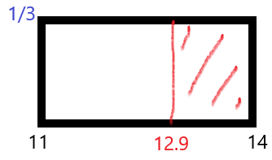
Again use the area formula: $A=bh= \left(14-12.9\right)\frac{1}{3}=0.3667$
Next to find that probability that at least 9 of them will be older than 12.9 years old, we use the rule of complements:
$P\left(x≥9\right)=1-P(x≤8)$. Now use the binomial cdf with
$n = 15, p = 0.3667, x = 8$ to get 0.0565.

- What is the 29th percentile of local middle school students? Be sure to include your diagram.
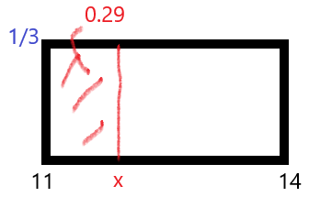
We use the area formula again to get: $A=bh, 0.29=(x-11)(\frac{1}{3})$
Multiply both sides by 3 to get: $0.87=x-11$. Now add 11 to both sides to get $x=11.87$. 11.87 is the 29th percentile.
- Using the definition that an outlier has a z-score less than -2 or greater than 2, is an 11.1 year old local middle school student an outlier?
First find the mean and the standard deviations using the formulas:
$$μ=\frac{a+b}{2}=\frac{11+14}{2}=12.5, σ=\sqrt{\frac{{\left(b-a\right)}^{2}}{12}}=\sqrt{\frac{{\left(14-11\right)}^{2}}{12}}=.8660$$
Now use the z-score formula: $z=\frac{x-μ}{σ}=\frac{11.1-12.5}{.8660}=-1.62$. Since
$-2<-1.62<2$, 11.1 is not an outlier.

Problem 5 (20 Points) How many times a week do Californians go out to eat? Ten Californians were asked how many times they ate out last week. The results are shown below.
Days | 3 | 7 | 0 | 6 | 5 | 2 | 0 | 1 | 4 | 3

- Determine the appropriate 95% confidence interval.
Use TInterval to get [1.3657,4.8343]

- Write a sentence that explains your findings.
With 95% confidence, the population mean number of times that Californians go out to eat per week is between 1.4 and 4.8 times per week.

- Use a sentence or two to explain what it means in the context of this study to be 95% confident.
If all samples of ten Californians are looked at, each will produce its own confidence interval. 95% of these intervals will contain the true population mean number of times per week Californians go out to eat.

- Was it necessary to make any assumptions about the underlying distribution of the population? Explain.
Yes, since $n=10<31$, the Central Limit Theorem does not give us that the sampling distribution is Normal. We therefore must assume it is normal.

Problem 6 (20 Points) A researcher wanted to estimate the proportion of squirrels that make it through the winter.
- If the researcher wants to construct an 82% confidence interval with a margin of error of plus or minus 5%, at least how many squirrels must be observed?
We use the formula: $n=0.25\frac{z^{2}}{E^{2}}$ . We have E = 0.05. To get z, note that 0.82 is inside the confidence interval, so 1-0.82 = 0.18 is outside, both left and right. To get just the left side, divide by 2 to get 0.09. Now take invnorm with mean 0 and standard deviation 1 to get z = -1.3408. Put it into the formula to get
$n=0.25\frac{{(-1.3408)}^{2}}{{0.05}^{2}}=179.77$. Observe 180 squirrels.
- Suppose that the researcher instead observed 400 squirrels and 284 of them made it through the winter. Determine the appropriate 95% confidence interval.
Use 1PropZInt to get [0.6655,0.7545].
- Write a sentence that explains your findings from part B.
With 95% confidence, between 67% and 75% of all squirrels make it through the winter.

Problem 7 (20 Points) According to the Federal Reserve, only 27 percent of college graduates work in a field related to their major. A researcher hypothesizes that the percent is greater for graduates who started out at a community college. The researcher surveyed 1015 graduates who started out at a community college and 290 of them work in a field related to their major.
- Write down the appropriate null and alternative hypotheses and find the test statistic and the P-Value for this study.
$$H_{0}: p=0.27$$$H_{1}: p>0.27$ Use 1PropZTest to get $z=1.1277$ P-Value = 0.1297
- Use a complete sentence to state the results in the context of the survey using a level of significance of 0.05.
There is statistically insignificance evidence to make a conclusion about whether the percent of all college graduates who started out at a community college work in a field related to their major.
- The P-Value represents a probability. Write a few sentences that interpret this probability in the context of the study.
If 27% of all college graduates who started out at a community college work in a field related to their major and another 1015 were surveyed then there would be a 13% chance that at least 290 of them work in a field related to their major.
- The level of significance represents a probability. Write a few sentences that interpret this probability in the context of the study.
If 27% of all college graduates who started out at a community college work in a field related to their major and another 1015 were surveyed then there would be a 5% chance that the new study would lead us to falsely conclude that more than 27% % of all college graduates who started out at a community college work in a field related to their major.

Problem 8 (20 Points) The box plot below shows the number of customers each day who entered the Tahoe Brewery.
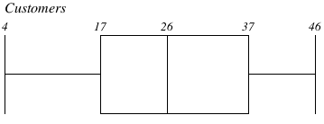

- What is the probability that a random day will have fewer than 37 customers?
0.75

- What is the probability that a random day will have more than 26 customers given that that there were fewer than 37 customers on that day?
$$P\left(x>26 | x<37\right)= \frac{P(26<x<37)}{P(x<37)}=\frac{0.25}{0.75}=\frac{1}{3}$$

- If tomorrow there was only 1 customer and that data value was added to the data set, would the standard deviation go down, up, or stay the same? Explain.
Since 1 is far from the mean compared to the rest of the data, the average distance from the mean will be larger, so the standard deviation will go up.

Problem 9 (Extra Credit) Credit will be given for any honest answers.
- Write down one thing that your instructor can do or could have done for you to help you better succeed in this online course.

- Write down one thing that your instructor did for you that helped you succeed in this online course.

- Write down one thing that you can do for yourself to help you better succeed in this online course.

- Write down one thing that you have done for yourself to help you better succeed in this online course.

