Essay 2: Evaluating an Argument

For this assignment, you will read the article titled, “Keeping the Promise to All America’s Children” on page 165 in your textbook. Then, you will write an essay in which you evaluate the author’s argument. This does NOT mean that you should agree or disagree with the author (his or her actual point); you are NOT commenting on the author’s opinion.

You will need to restate his thesis/argument in your own words and from then on, show how he or she did an effective or ineffective job at convincing the audience, meaning you have to identify it. Identify the argument and audience in your introduction. Then, write your own thesis, which should state whether the presented argument is effective or not and why, and then, spend the body paragraphs focusing on the different strategies and how they are being used.

Task: You are analyzing the way the author presented his or her argument to argue whether it is an effective or ineffective argument.

In order to analyze the argument, you will consider the author’s use of:
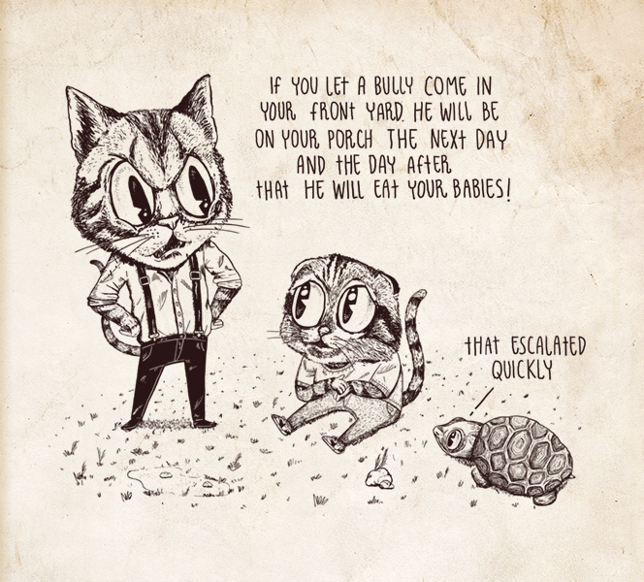
- Pathos
- Ethos
- Logos
- Assumptions
- Logical fallacies
- Tone
- Types/Strength of evidence
- Objectivity/Bias
- OR any other points you saw in your textbook

Ask yourself, what makes for an effective argument? How and in what ways is the argument convincing?

*Remember that the author can use one rhetorical strategy effectively while failing to use others effectively.

Directions:

You will need to:
- Point out any instances where the author used one of the elements above by providing a quote from the text with MLA citation.
- Comment on whether or not the author did so well, and why? And whether the use of this strategy contributed to effectiveness of his or her argument.

You do NOT have to address every elements above, but you DO have to evaluate a minimum of FIVE (5). Each of the five can be presented in its own separate paragraph or you may combine them as you see fit. Be aware that I do expect to see clear organization and academic essay structure.

Due Dates:

- Rough Draft Due Sunday
- Final Draft Due Sunday of Week 9

Requirements:

- Length: 3-5 pages
- You will need
- Introduction (including a hook, background information about the article, the author’s thesis/claim and his intended audience and your thesis/claim)
- Up to 5 body paragraphs (including examples from the text as well as your analysis of effectiveness)
- Conclusion

