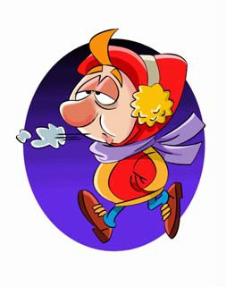
Transitions

DIRECTIONS: Create an original sentence or pair of sentences using the transitions indicated.

- meanwhile

- for example

- consequently

- without a doubt

- therefore

CCSS W.4.1.C |© http://www.englishworksheetsland.com

