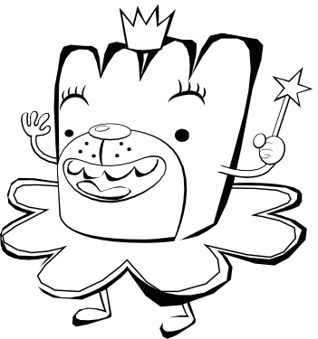
Linking Ideas with Transition Words

Why are Linking Words and Phrases important?
- They introduce new ideas.
- They connect key information (facts and details) in our writing by showing:
  - Time order • Compare and Contrast
  - Examples • Emphasis
  - Additional information • Conclusions

Directions: Based on the other transitions in the passage, choose a good transition word to use in each blank. Circle the best transition and write it on the line.

- Each winter, my family and I choose a location to visit for a family trip. We love to travel!

, we think about what activities we could do in each place. We try to find
First Next
things that we would all enjoy. , we check out flights and hotels to see if
Also Then
there are any great deals. , we choose a destination and begin planning
Finally However
specific details.

- Exercise is something that people do for physical wellness. , exercise
For example In addition
provides benefits to our mental health. Exercise is done for many reasons. , it
For example But
helps reduce stress, increase weight loss, and strengthen muscles. Many people enjoy the act of

exercising. health benefit of exercise is that it helps us to sleep better. Sleep,
Another Also
healthy food choices, and exercises are all part of a positive lifestyle. , the
And In conclusion
health benefits of exercise can improve a person’s life.

- Imagine a cafeteria in which all students could sit wherever they wanted, regardless of class.

, some students may wish to choose their seats. , some
On one hand After On the other hand Also
students may rather have assigned seats. I believe that we should be able to choose our own seats.

, students would be able to talk to their friends at lunch instead of during the
As a result To begin
teacher’s lesson. , choosing seats at lunch would allow students to make new
In conclusion Also
friends. , school is about both academic learning as well as social learning.
Finally To start
, we should pick our own seats.
Then To conclude

Copyright © 2018 Education.com LLC All Rights Reserved More worksheets at www.education.com/worksheets

