Lab 0: Measurement

Contents:  - Introduction.…………………………………………………………………..  - Averaging, Errors & Uncertainty Exercises……………………………….  - Collecting & Analyzing Data………………………………………………..  - Questions/Conclusions….………………………………………………….. | 1  2  6  9

I. INTRODUCTION
Any time a measurement is made there is an associated, inherent uncertainty. This uncertainty is a function of both the device used to perform the measurement and experimenter/environment. If repeated measurements have been taken, statistical analysis may be used to determine the uncertainty in the measurement process. In this lab you will learn how to use statistics to determine the uncertainty for a repeated measurement. There will be some basic rules associated with the reporting of the uncertainty.

Rules for Uncertainties:
- The uncertainty should only have one significant digit.
For example, when the standard deviation of the measurements is calculated you might obtain a value such as 0.03567 cm, this should be reported as the uncertainty in your measurement as 0.04 cm. Since, the first significant digit is the three, but the next digit is a five so then you would round the three up to a four.
- Always round your reported result.
This will be the average of the repeated measurements, to the same place as the place in which the one significant digit in the uncertainty occurs. For example, if your average were 23.672 cm then you would report your measurement as 23.67 cm, which is rounded to the hundredths place. Otherwise, it appears that your result is more (or less) accurate than indicated by the uncertainty.
- Both your measurement and your uncertainty must have units and they really should be reported with the same units.
For example, your final result would be reported to be 23.67 cm ± 0.04 cm or (23.67 ± 0.04) cm. Also if your result is supposed to be reported in scientific notation, then they should both have the same power of ten based upon the result and not the uncertainty. You will move the decimal place the same way in the uncertainty as you did in the result and usually the power of ten is then factored out of the result as a common factor follows: (2.367 ± 0.004) * 10¹ cm.

Lab objectives:
- Learn about measurement techniques and data collection and processing with a specific emphasis on error analysis through a series of readings and exercises.
- Apply knowledge gained in the first part of the lab by performing two different types of measurements and achieving calculated results.

II. AVERAGING, ERRORS & UNCERTAINTY EXERCIZES
Types of Error
There are three types of limitations to measurements:
- Instrumental limitations
Any measuring device can only be used to measure to with a certain degree of fineness. Our measurements are no better than the instruments we use to make them. These should be included in your recorded and calculated values!
- Systematic errors and blunders
These are caused by a mistake, which does not change during the measurement. For example, if the platform balance you used to weigh something was not correctly set to zero with no weight on the pan, all your subsequent measurements of mass would be too large. Systematic errors do not enter into the uncertainty. They are either identified and eliminated or lurk in the background producing a shift from the true value. If you identify these they should be either calculated out of your results or, if that is not possible, the experiment needs to be repeated!
- Random errors
These arise from unnoticed variations in measurement technique, tiny changes in the experimental environment, etc. Random variations affect precision. Truly random effects average out if the results of a large number of trials are combined.

Precision vs. Accuracy

- A precise measurement is one where independent measurements of the same quantity closely cluster about a single value that may or may not be the correct value.
- An accurate measurement is one where independent measurements cluster about the true value of the measured quantity.
Systematic errors are not random and therefore can never cancel out. They affect the accuracy but not the precision of a measurement.

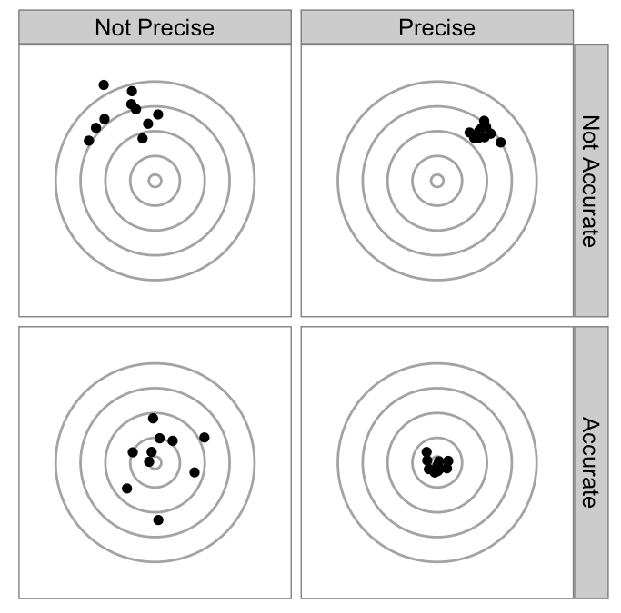
- Low‐precision, Low‐accuracy:
The average (the X) is not close to the center
- Low‐precision, High‐accuracy:
The average is close to the true value
- High‐precision, Low‐accuracy:
The average is not close to the true value

Writing Experimental Numbers
Uncertainty of Measurements
Errors are quantified by associating an uncertainty with each measurement. For example, the best estimate of a length L is 2.59 cm, but due to uncertainty, the length might be as small as 2.57 cm or as large as 2.61 cm. L can be expressed with its uncertainty in two different ways:
- Absolute Uncertainty
Expressed in the units of the measured quantity: L = 2.59 ± 0.02 cm
- Percentage Uncertainty
Expressed as a percentage which is independent of the units
Above, since 0.02/2.59 ≈ 1% we would write L = 2.59 ± 1%

Significant Figures
Experimental numbers must be written in a way consistent with the precision to which they are known. In this context one speaks of significant figures or digits that have physical meaning.
- All definite digits and the first doubtful digit are considered significant.
- Leading zeros are not significant figures.
Example: L = 2.31 cm has 3 significant figures. For L = 0.0231 m, the zeros serve to move the decimal point to the correct position. Leading zeros are not significant figures.
- Trailing zeros are significant figures: they indicate the number’s precision.
- One significant figure should be used to report the uncertainty or occasionally two, especially if the second figure is a five.

Rounding Numbers
To keep the correct number of significant figures, numbers must be rounded off. The discarded digit is called the remainder. There are three rules for rounding:
- Rule 1: If the remainder is less than 5, drop the last digit.
Rounding to one decimal place: 5.346 → 5.3
- Rule 2: If the remainder is greater than 5, increase the final digit by 1.
Rounding to one decimal place: 5.798 → 5.8
- Rule 3: If the remainder is exactly 5 then round the last digit to the closest even number. This is to prevent rounding bias. Remainders from 1 to 5 are rounded down half the time and remainders from 6 to 10 are rounded up the other half.
Rounding to one decimal place: 3.55 → 3.6, also 3.65 → 3.6

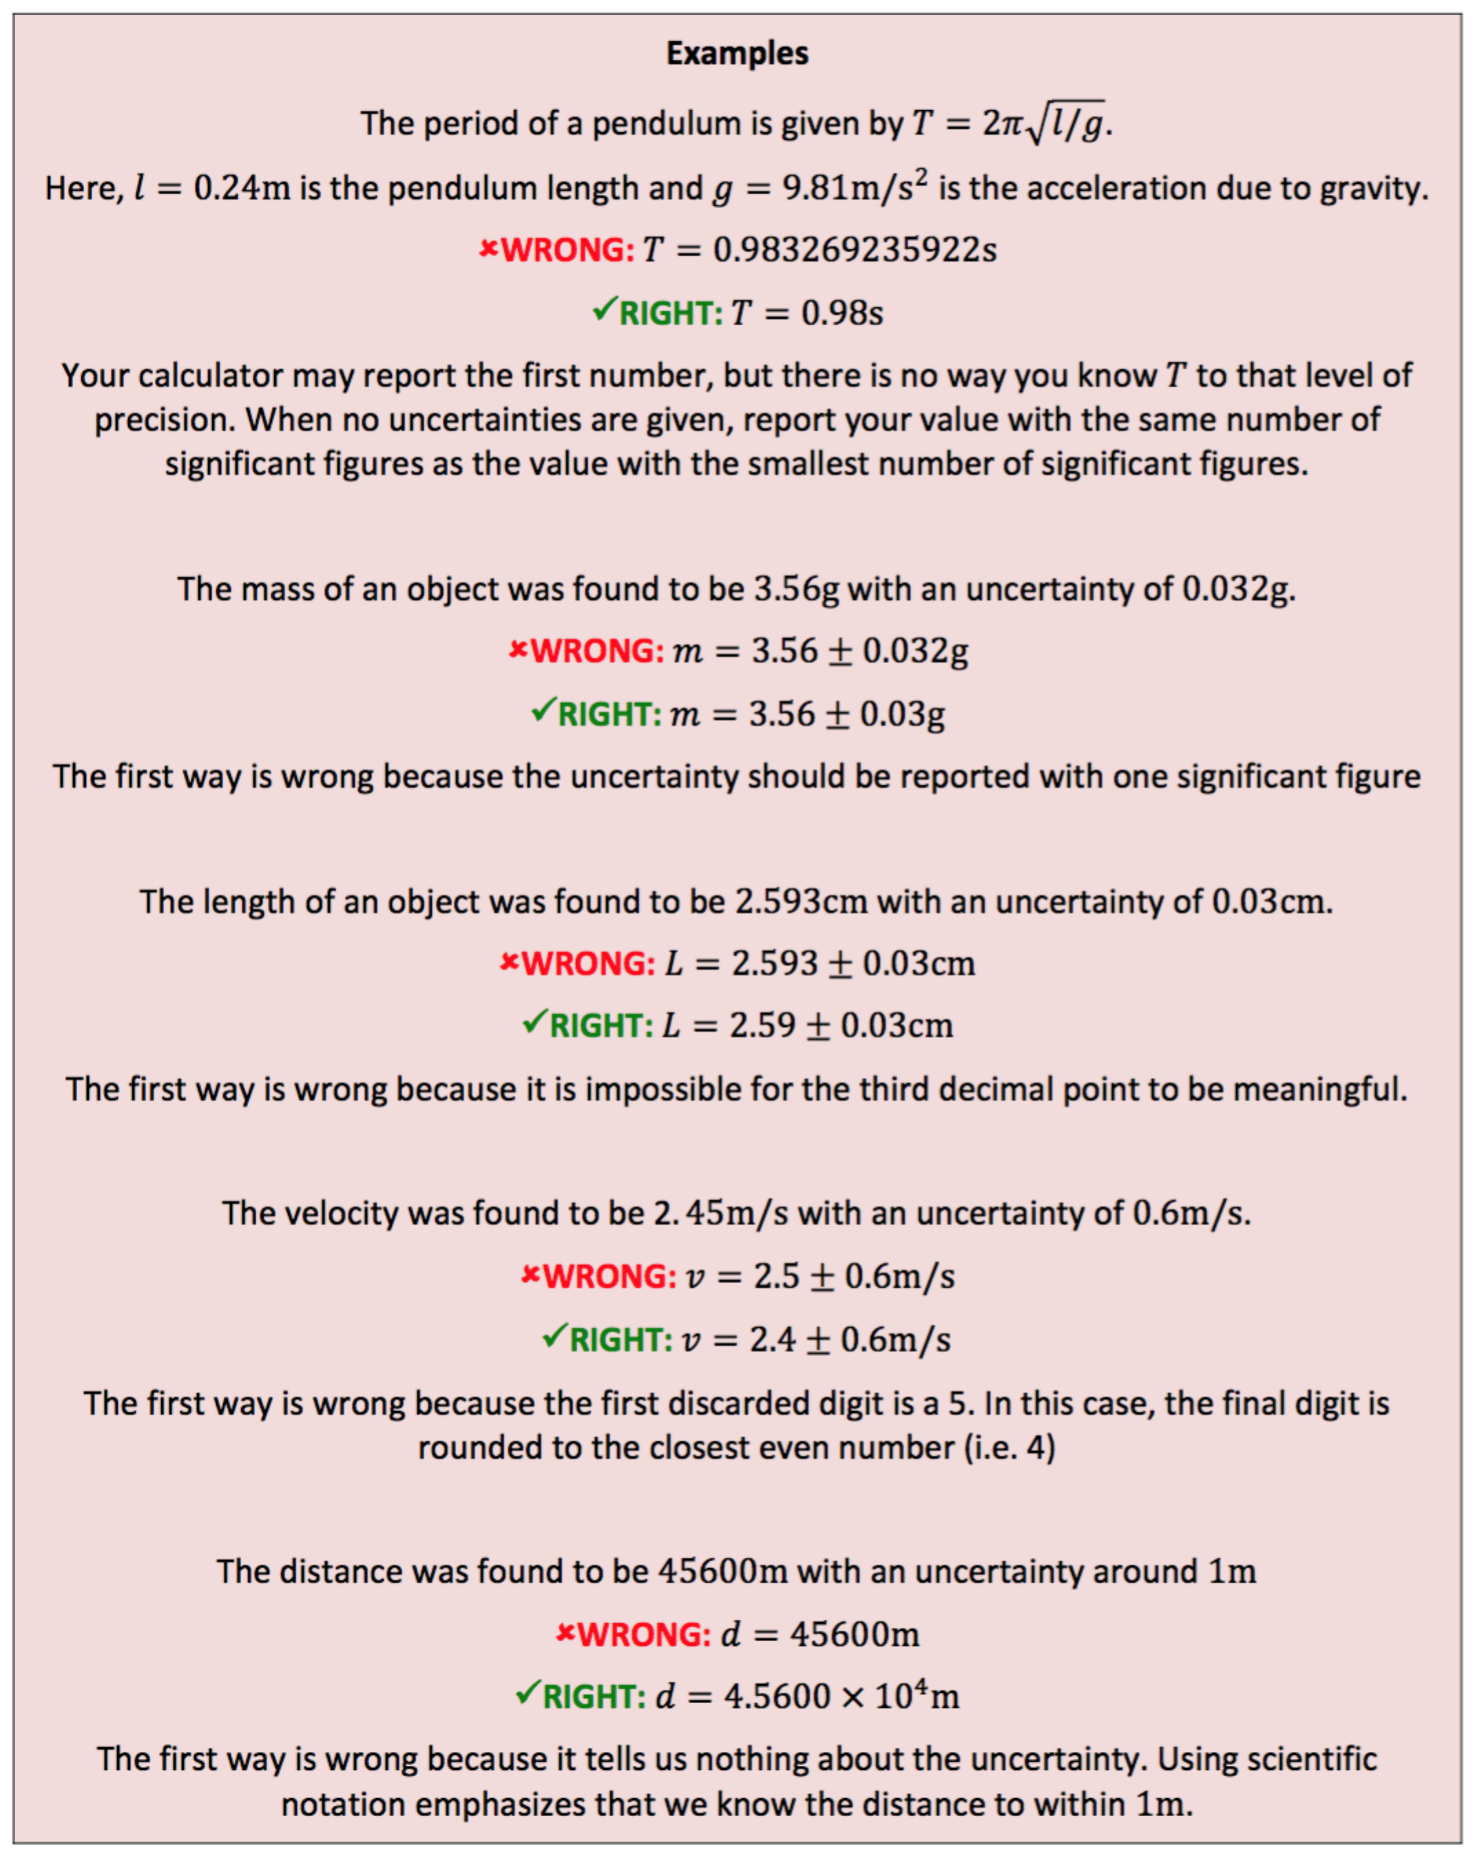
Statistical Analysis of Small Data Sets
Repeated measurements allow you to not only obtain a better idea of the actual value, but also enable you to characterize the uncertainty of your measurement. Below are a number of quantities that are very useful in data analysis. The value obtained from a particular measurement is x. The measurement is repeated N times. Oftentimes in lab N is small, usually no more than 5 to 10. In this case we use the formulae below:
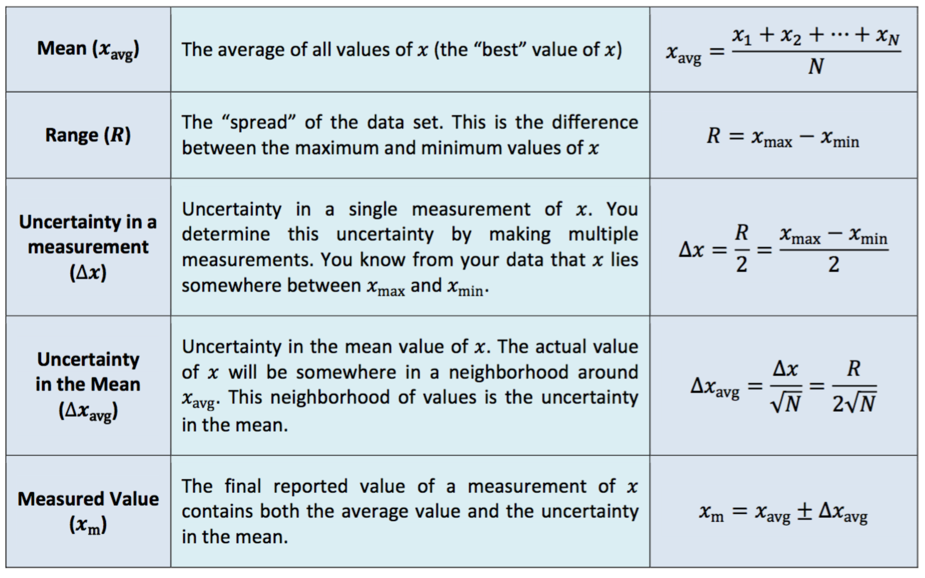
The average value becomes more and more precise as the number of measurements N increases. Although the uncertainty of any single measurement is always ∆x, the uncertainty in the mean ∆x_{avg} becomes smaller (by a factor of $1/{\sqrt{N}}$) as more measurements are made.

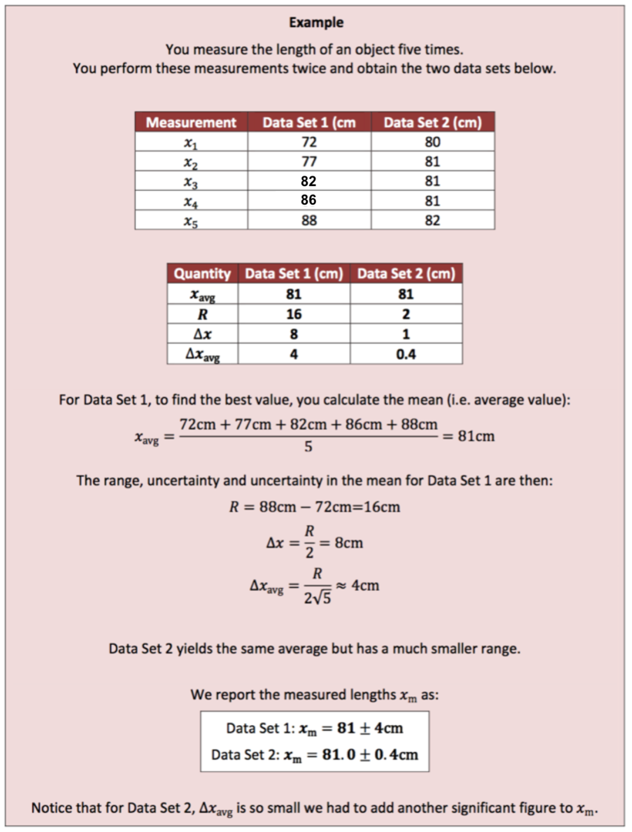

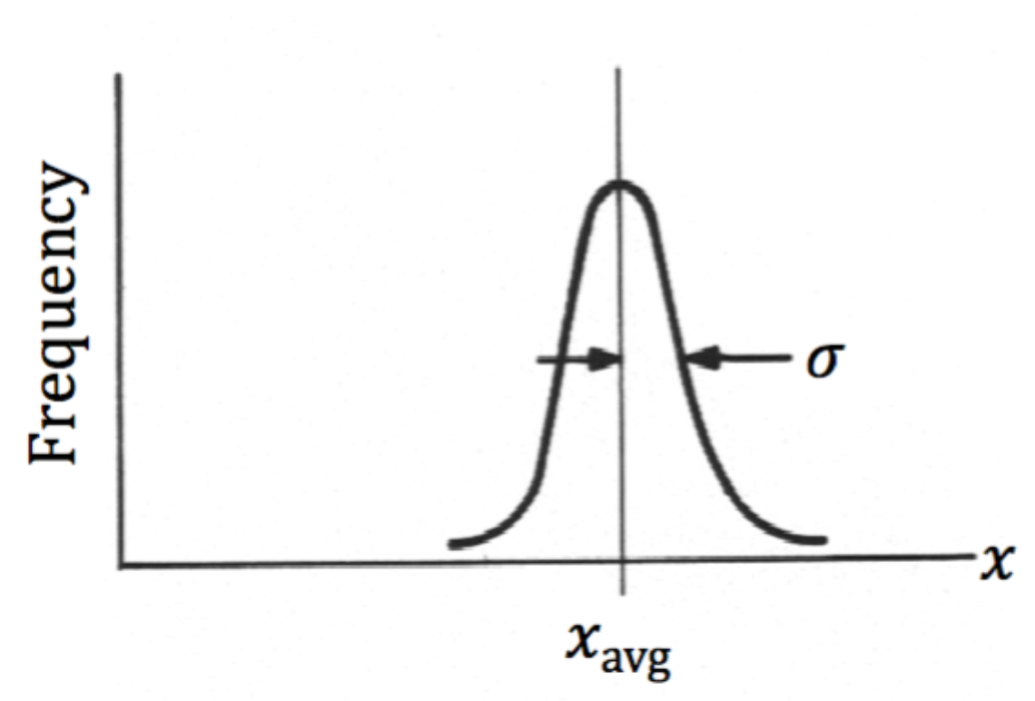
Statistical Analysis of Large Data Sets
If only random errors affect a measurement, it can be shown mathematically that in the limit of an infinite number of measurements (N → ∞), the distribution of values follows a normal distribution (i.e. the bell curve on the right). This distribution has a peak at the mean value x_{avg} and a width given by the standard deviation σ.
Obviously, we never take an infinite number of measurements. However, for a large number of measurements, say, ~10 - 10² or more, measurements may be approximately normally distributed. In that event we use the formulae below:
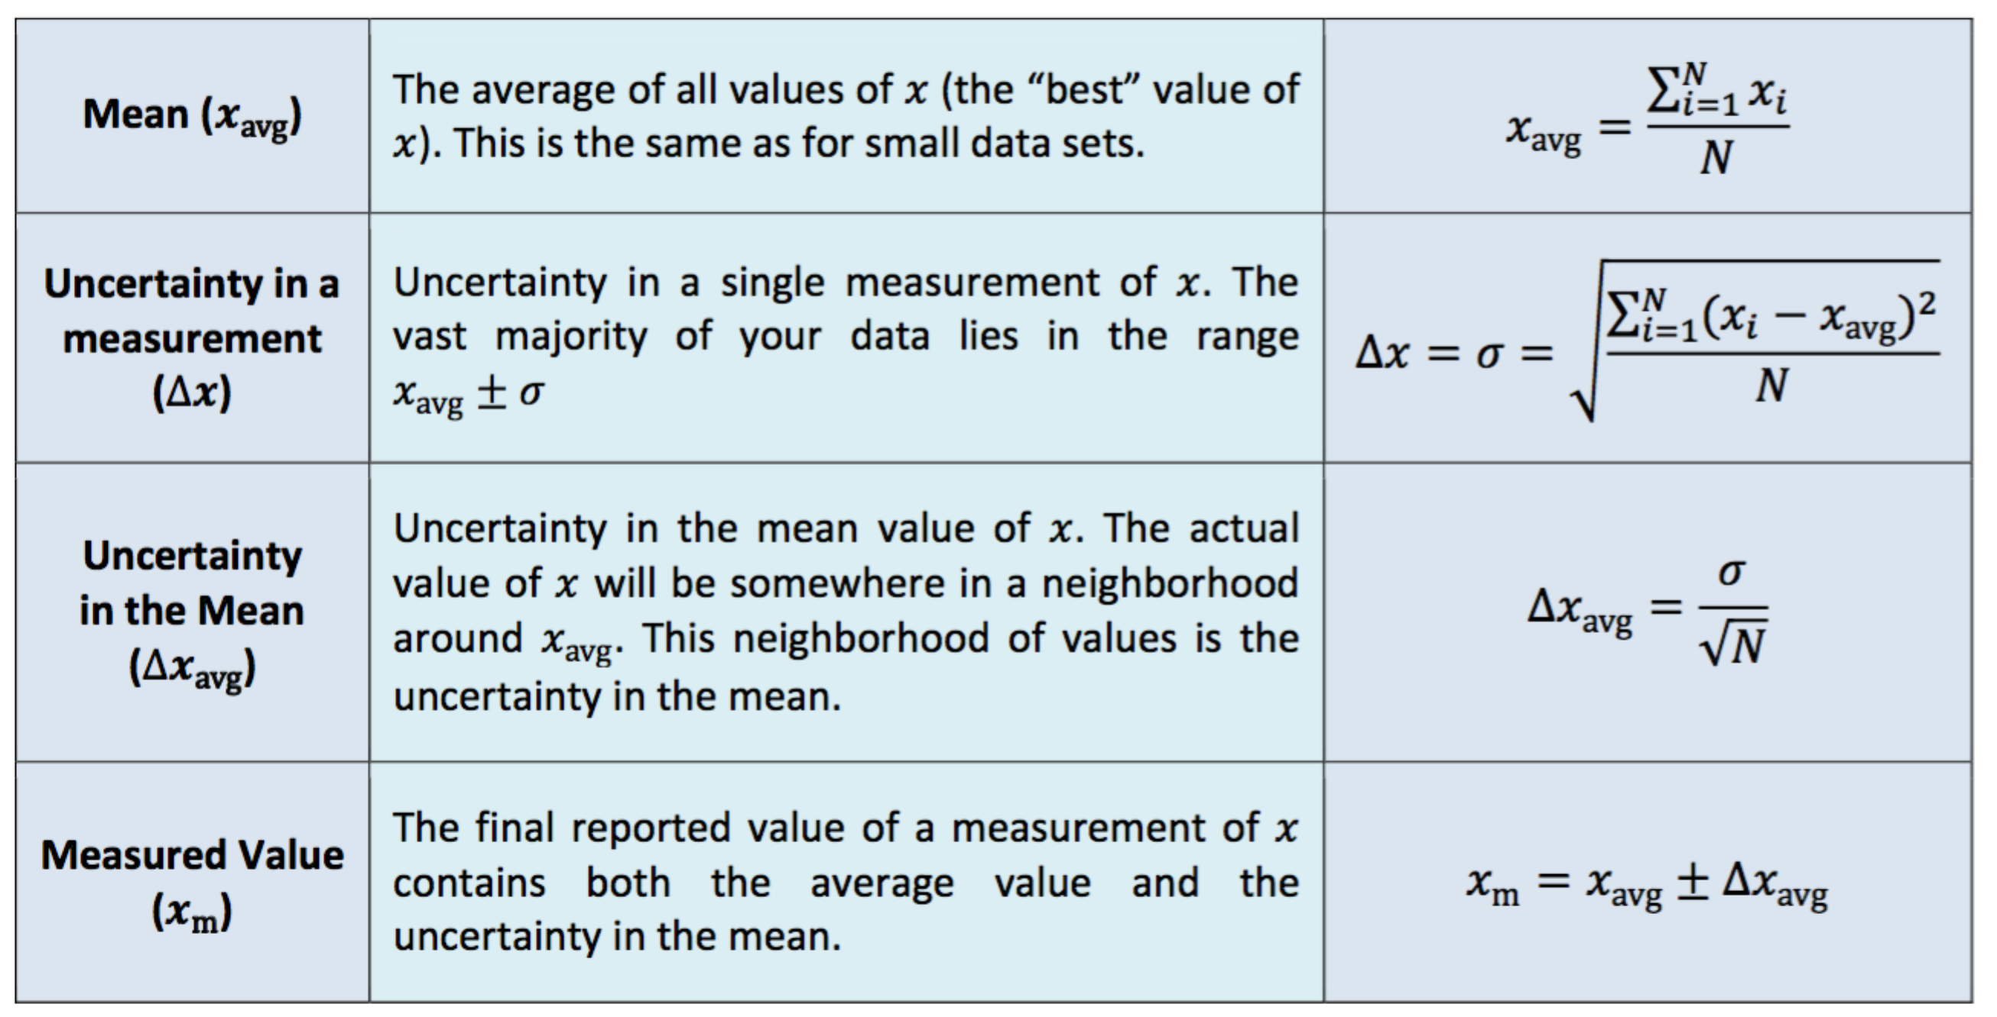
Most of the time we will be using the formulae for small data sets. However, occasionally we perform experiments with enough data to compute a meaningful standard deviation. In those cases we can take advantage of software that has programmed algorithms for computing x_{avg} and σ.

Propagation of Uncertainties
Oftentimes we combine multiple values, each of which has an uncertainty, into a single equation. In fact, we do this every time we measure something with a ruler. Take, for example, measuring the distance from a grasshopper’s front legs to his hind legs. For rulers, we will assume that the uncertainty in all measurements is one‐half of the smallest spacing.
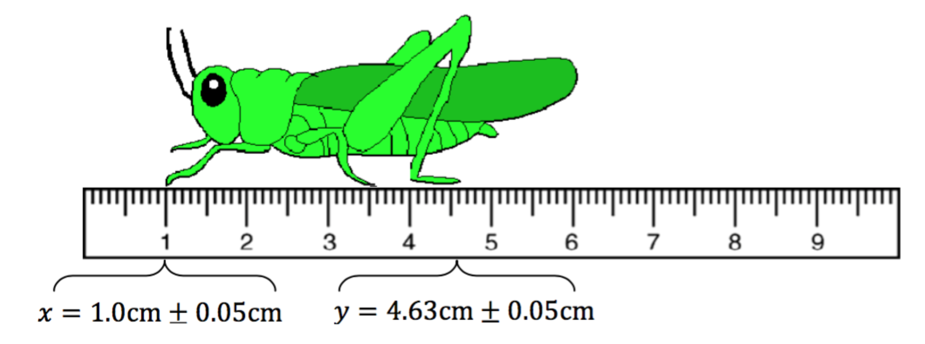
The measured distance is d_{m} = d ± ∆d where d = 4.63 cm -1.0 cm = 3.63 cm. What is the uncertainty in d_{m}? You might think that it is the sum of the uncertainties in x and y (i.e. ∆d = ∆x + ∆y = 0.1 cm). However, statistics tells us that if the uncertainties are independent of one another, the uncertainty in a sum or difference of two numbers is obtained by $Δd=\sqrt{{\left(Δx\right)}^{2}+{\left(Δy\right)}^{2}}=0.07\text{cm}$. The way these uncertainties combine depends on how the measured quantity is related to each value. Rules for how uncertainties propagate are given below.
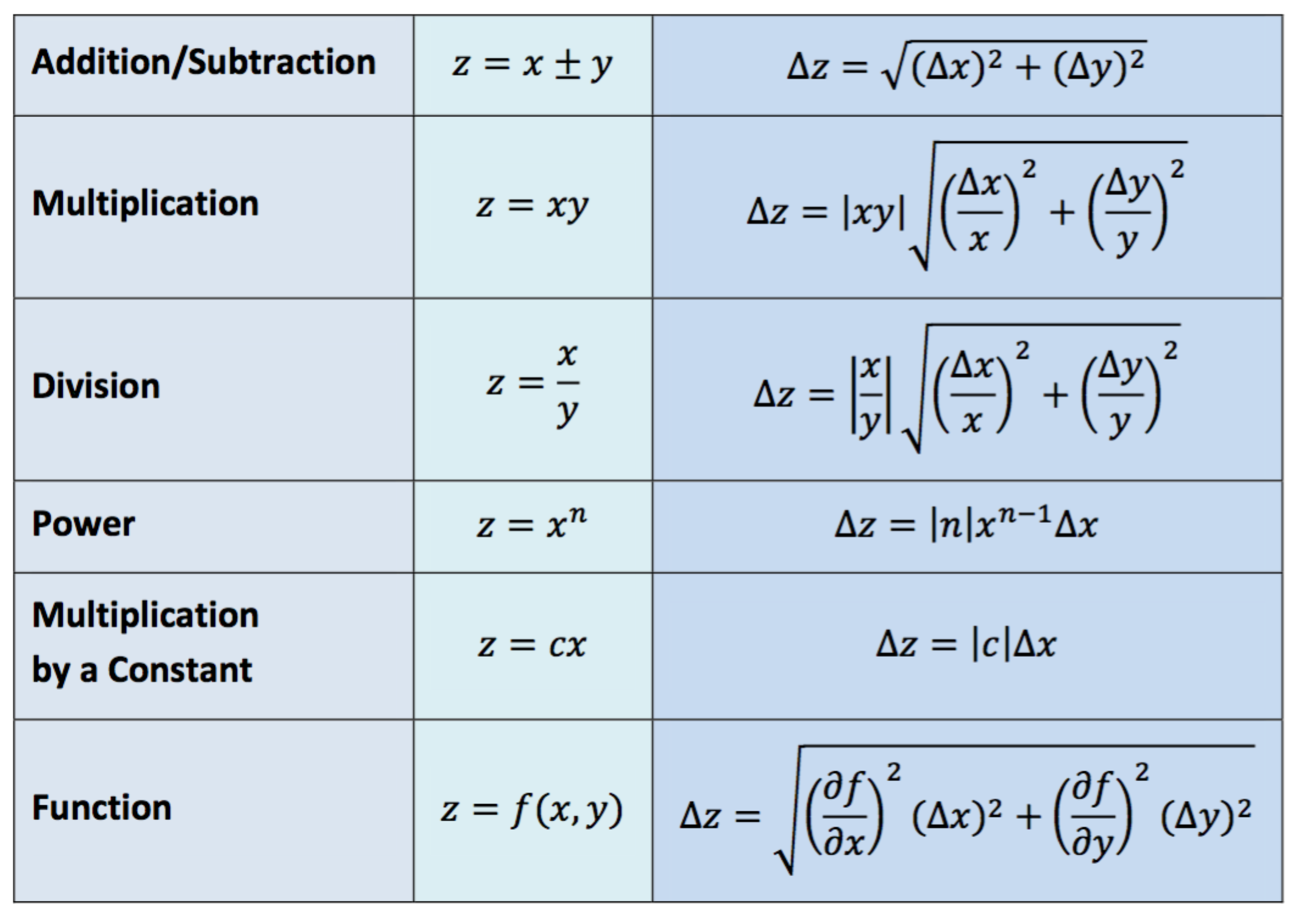
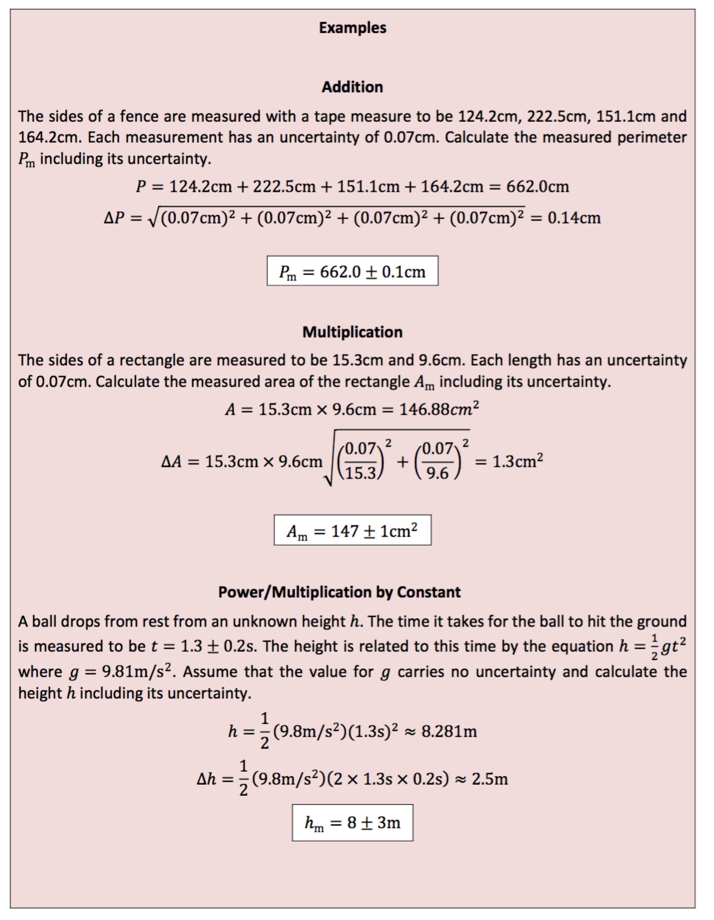

Problems
- State the number of significant figures in each of the following numbers and explain your answer.
  - 37.60
  - 0.0130
  - 13000
  - 1.3400
- Perform the indicated operations to the correct number of significant figures using the rules for significant figures.
  - $37.60∗1.23=$
  - ${9.975}/{6.7}=$
  - $3.765+1.2+37.21=$
3-7. Three students named Amer, Barb, and Cal make measurements (in m) of the length of a table using a meter stick. Each student's measurements are tabulated in the table below along with the mean, the standard deviation from the mean, and the standard error of the measurements. Note that in each case only one significant figure is kept in the average uncertainty (Δx_{avg}), and this determines the number of significant figures in the mean. The actual length of the table is determined by very sophisticated laser measurement techniques to be 1.4715 m.
 | Amer | Barb | Cal
x₁ | 1.4717 | 1.4753 | 1.4719
x₂ | 1.4711 | 1.4759 | 1.4723
x₃ | 1.4722 | 1.4756 | 1.4727
x₄ | 1.4715 | 1.4749 | 1.4705
x_{avg} | 1.4716 | 1.4754 | 1.4719
R | 0.0011 | 0.0010 | 0.0022
Δx | 0.0006 | 0.0005 | 0.0011
Δx_{avg} | 0.0003 | 0.0002 | 0.0006

- Write the measured lengths for each of the students.
- State how one determines the accuracy of a measurement. Apply your idea to the measurements of the three students above and state which of the students has the most accurate measurement. Why is that your conclusion?
- Calculate the mean, range, uncertainty in the measurement, and uncertainty in the mean for Amer's measurements of length. Confirm that your calculated values are the same as those in the table. Show your calculations explicitly.
Amer
x_{avg}
R
Δx
Δx_{avg}

- State the characteristics of data that indicate a systematic error. Do any of the three students have data that suggest the possibility of a systematic error? If so, state which student it is, and state how the data indicate your conclusion.
- Which student has the best measurement considering both accuracy and precision? State clearly what the characteristics are of the student's data on which your answer is based.

III. COLLECTING & ANALYZING DATA
Materials/Equipment
Plastic ruler and meter stick (or comparable measuring devices), table in your home

Measurement 1: Lab Table
- Procedure
Measure the length and width of a table 10 times, first with the meter stick and then with the plastic ruler. When you are finished, average the values to get a better measure of the piece’s true length. Make an “eyeball” estimate of your uncertainties. Keep in mind that the better and more precise/accurate your technique (as described below) the better your grade will be.
- Data Collection

 | Meter Stick |  | Plastic Ruler
Trial | L (m) | W (m) | L (m) | W (m)
1
2
3
4
5
6
7
8
9
10
Avg
R
Δx
Δx_{avg}

- Data Analysis
- Describe (in full, grammatically correct sentences) your measurement technique for the measuring length and width with
  - the meters stick
  - the ruler
- Why do we need to take so many measurements?
- Write out the length and width of the table including uncertainty.
  - For the meters stick
  - for the ruler
- Explain the possible sources of error in this measurement. How did you come up with the number of significant figures you used?
- How well did your measurements with the meter stick agree with those done with the smaller, plastic ruler? If there was a disagreement, what kind of error was it? Random or systematic? What caused this error?

- Calculations
- Calculate area of table including the propagation of uncertainty (explained in the previous section).
- Calculate perimeter of table including propagation of uncertainty (explained in the previous section)

IV. QUESTIONS/CONCLUSIONS
- Which of your measurements was the most uncertain? Why?
- Which of your measurements was the least uncertain? Why?
- Which measurements, if any, suffered from systematic error? Explain.

