Lab 3 – Forces and Motion

Name: ____________________________________________________

Objectives
- To explore the forces acting on a body that rests on Earth surface.
- To explore unbalance forces.
- To understand the effect of the forces of friction during the motion of objects.
- To explore experimentally the Second Newton’s Law (relation between force, mass and acceleration)

In your responses use scientific terms such as, constant, increase, decrease, velocity, force, mass and acceleration.

Click on the link below to open the simulation:
http://phet.colorado.edu/sims/html/forces-and-motion-basics/latest/forces-and-motion-basics_en.html.

Your screen should look like the following.

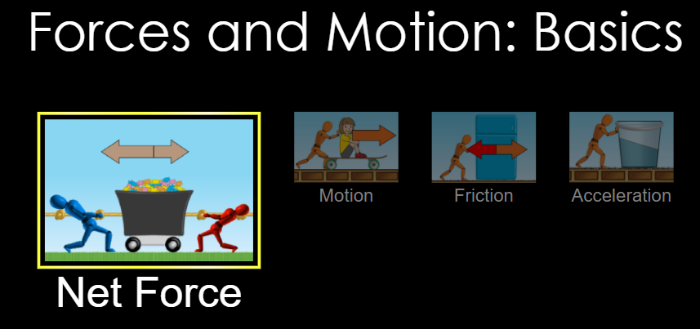

Part I. Net force.

- Click on “Net Force”
- Select the checkboxes: Sum of Forces, Values and Speed

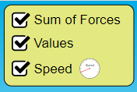
- The different in size of each of the rope’s pullers, correspond to a difference in the magnitude of the applied force, such that:

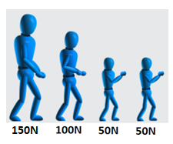
- Apply a 200N force to the left rope, and 150 N to the right rope. What is the magnitude and direction of the Resultant Force? __________________________

- Click on “Go”. In what direction is the car moving? ________________________

- Observe the speedometer on the car. As the car moves, what is happening with the velocity? ______________________________________________________

Explain the cause of the velocity’s behavior ______________________________
__________________________________________________________________
__________________________________________________________________

Part II. Motion

- Click on “Motion” at the bottom.

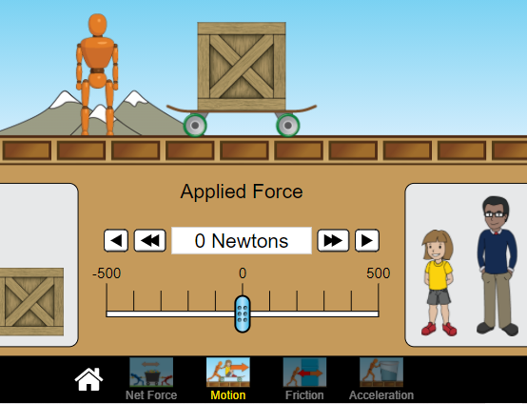

- Select the checkboxes: Forces, Values, Masses and Speed

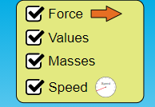

- Push the skateboard and the box with a force of 500N. Observe and describe the behavior of the velocity once the skateboard is released____________________
__________________________________________________________________

Explain the reason of such behavior ____________________________________
__________________________________________________________________

Part III. Friction
- Click on “Friction” at the bottom.
- Select the checkboxes: Forces, Sum of Forces, Values, Masses and Speed. Keep the knob that regulates the friction at the center of the scale.

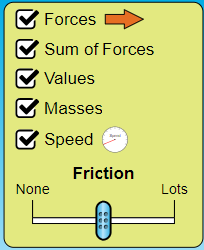

- Start to push the box, increasing the force applied on the box slowly. There is a force that is opposite to the force you are applying. What is the name of the force opposing to the motion? _____________________________________

- Once the box start moving, the magnitude of the resultant force increase instantaneously. How do you explain that?
__________________________________________________________________
__________________________________________________________________

- Push the box and find the force needed to make the box to start moving. Add more mass (box, kid, man, refrigerator, basket as needed) and repeat the procedure such that you complete the table below.
Hint:
Weight = mass x gravity
Magnitude of Normal Force = Magnitude of the Weight

Mass (kg) | Weight (N) | Normal Force (N) | Force of Static Friction (N)
50
90
130
150
180

- Use a graphing program to graph Normal Force vs. Force of Static Friction, plotting points and drawing the curve that better fit those points. Set the normal force as the x-axis, and the force of static friction as the y-axis.

- Find the slope of the line: Slope = ________________________

- What does the slope represent? _____________________________

- The following website presents the coefficients of static friction for different pairs of materials: https://mechguru.com/machine-design/typical-coefficient-of-friction-values-for-common-materials/

If Material 1 is Aluminum (Al), what material should be the Material 2, according with the value obtained in question 8? ________________________________.

- Push the box and find the force needed to make the box to stay moving (Force opposing the motion). Add more mass (box, kid, man, refrigerator, basket as needed) and repeat the procedure such that you complete the table below.
Hint:
Weight = mass x gravity
Magnitude of Normal Force = Magnitude of the Weight

Mass (kg) | Weight (N) | Normal Force (N) | Force of Kinetic Friction (N)
50
90
130
150
180

- Use a graphing program to graph Normal Force vs. Force of Kinetic Friction, plotting points and drawing the curve that better fit those points. Set the normal force as the x-axis, and the force of kinetic friction as the y-axis.

- Find the slope of the line: Slope = ________________________

- What the slope represents? _____________________________

Part IV. Finding the Acceleration
- Click on “Acceleration” at the bottom.
- Select the force, mass and using Newton’s Second Law of Motion, find the acceleration.
- Note down the initial velocity, final velocity and the time taken during this change and calculate the acceleration.
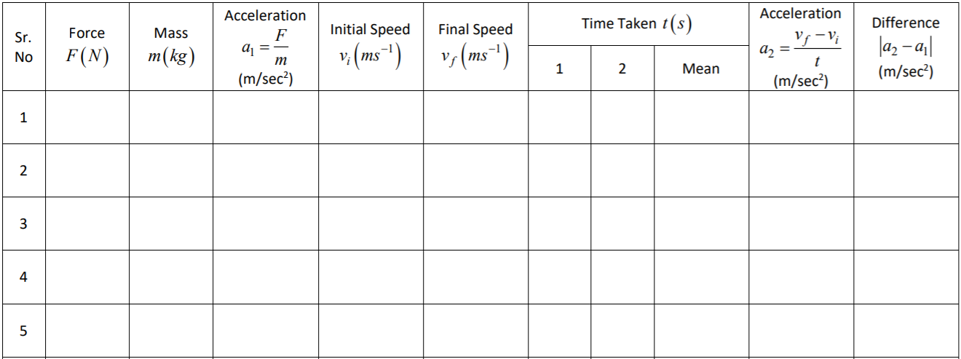
- Find the difference between the two accelerations.

